FOR IMMEDIATE RELEASE CONTACT: Robin Jones: 617-529-2490

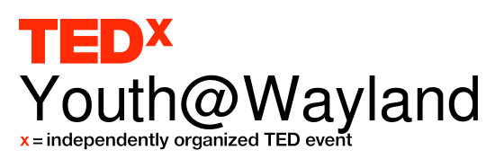
TEDxYOUTH@WAYLAND
Wayland hosts its first TEDx Event

Wayland, MA—April 27, 2015--- Wayland will host its first annual TEDx Event on May 9, 2015 from 2-6 p.m. at Wayland High School. The theme of this event is “Daring Greatly” and will showcase 13 Wayland middle and high school student speakers and 3 student performers. The event, started by Wayland resident Ashley Welch, is an opportunity to bring people together, share ideas, create and inspire conversation and understanding. This is a ticketed event and is open to the public.

“I have been to several TEDx events in Boston and each time I was so moved and inspired emotionally and intellectually. It brought me to a deeper level of connecting with the people around me and broadened my perspective,” said Welch. “It got me thinking that this is a perfect vehicle for creating community and should be done for Wayland, featuring our students who have so much to share with us.”

Welch pulled together a core team of Wayland parents, students and teachers to make this event a reality. The core group has matched each presenter with a volunteer coach from the Wayland community in an effort to prepare them for the May 9th event. Each talk will be 6-18 minutes and topics range from extraterrestrial life to micro-aggression, from beat boxing to transgender identity in our culture, from introverts in an extrovert’s world, to the power of volunteerism.

“The mission of any TEDx event is to curate an exceptional experience for the audience, and we promise it will be a treat for anyone present. Our speakers and performers are working incredibly hard to create their TEDx talks and to be ready for the 9th,” said Amy Sullivan-Wayland Parent and Core Team member.

“Our goal is to make sure these kids are fully supported and wildly successful at the event. I am so grateful to our volunteer community coaches--- some of whom have kids who have aged out of the Wayland schools and yet they are still giving of their time, energy and expertise; it’s extraordinary,” explained Welch.

Over 40 students auditioned for a speaking role and of those students, 13 were chosen to speak and 3 to perform. Those students are: Will Danforth (9th), Naiya Davis (11th), Anne Flaherty (11th), Tachianna Griffith (12th), Rachel Hawley (12th), James Hunt (12th), Hugh Jones (10th), Sylvia Lagor (7th), Jack McCahan (6th), Lila Massard (11th), Declan Nolan (12th), Daly Place (12th), Nour Sayeh (11th), Gabi Ragazzi (11th), Casey Troost (10th) and the T-Tones, a WHS A Cappella group.

The event is sponsored by WHS Principal Allyson Mizoguchi and the core team includes: Stephanie Galvani – MS teacher. Amy Sullivan - parent, Noelle McGah - 8th, Dale Lippincott - 8th, Devon Wong- 8th, Joanne Schmidt – WHS Librarian and Media Specialist, Mary Barbar – WHS Technology Specialist, Gabi Ragazzi – 11th, Stephanie Salitsky – parent, and Ashley Welch- parent.

The ticket price is $10 for students and $20 for Adults. Seating is limited. To purchase tickets or to donate to TEDxYouth@Wayland go to: https://www.ted.com/tedx/events/15584, or http://tinyurl.com/pqgzb3b or contact Ashley Welch at awelch743@gmail.com or 508-740-3506.

###

