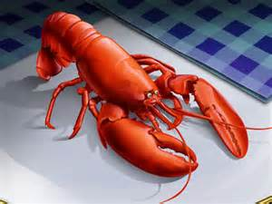**4TH Annual**

**Lobster Fest**

  WHEN: **Sunday October 4, 2015: 5:00pm—7:30pm**

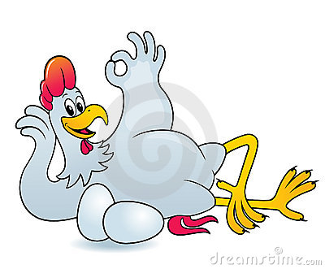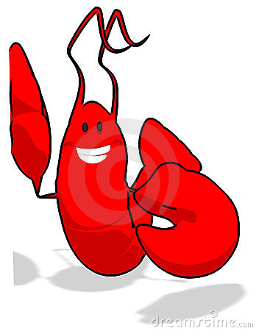

EAT MORE

STEAK!

WHERE: **Sandy Burr Country Club**

Invite your family, friends, and neighbors to this fun community event featuring live auction, raffles, the always popular beer and wine toss and more!

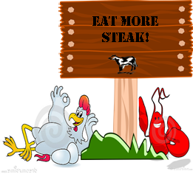



EAT MORE

*LOBSTER!*

EAT MORE *STEAK!*

BUFFET DINNER INCLUDES:

**Lobster ~** **Steak Tips** ~ **Chicken**

**Chowder ~ Salads** ~ **Watermelon**

**Ice Cream Sundaes**!

**Art Exhibit and Sale**

**Featuring Local Artists**

New this year!

TICKETS: **$60**



T MORE

STEAK!

Don’t delay - last year was a sell out!

Purchase a table of 8 and receive free raffle tickets!

Questions: Call the COA at 508-358-2990

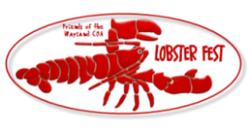Proceeds benefit the Friends of the Wayland Council on Aging

**Friends of the Wayland Council On Aging Inc. *is a 501(c)3 organization* *dedicated to the support of COA programs, services and equipment that cannot be financed through the COA’s Town Budget.***

**Tickets on sale after Labor Day at:**

**Village Bank, COA Office at the Wayland Town Building or Friends Board Members:**

*Sue Pope, Kathy Hodge, Mary Antes, Patty MacNeil, Steve Correia, Mary Kelly,*

*Dave D’Orlando, Betsy Willard, Sonja Strong, Jane Capasso, Nancy Leifer*

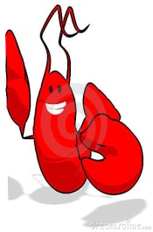

EAT MORE

STEAK!



EAT MORE

STEAK!



EAT MORE

STEAK!



EAT MORE

STEAK!



EAT MORE

STEAK!



EAT MORE

STEAK!